Software: collection of computer program that help us to performs a task

There are three types of software:

1. system

ex: driver, operating system, server

1. programming

ex: interpreter, compiler, interpreter

3) application

Ex: web application, mobile apps, desktop application

What is software testing?

Ans = the objective of testing is to realise the quality product to the client and it is activity to detect the defect in software

Software quality:

1. bug free
2. delivered on time
3. within budget
4. meets requirement
5. maintainable

project and product

if software application developed for specific costumer based on the requirement, then it is called as project or service-based ex: TCS, WIPRO, INFOSYS

if software is developed for multiple costumers based on the market requirement the it is called as product ex= Google, oracle, WhatsApp

### ERROR, BUG, & FAILURE:

ERROR: it is human mistake; it is incorrect human action while writing the program. This are committed by developer

BUG: bug it is a deviation from expected behaviour and actual behaviour it is called as bug and defect. This are found by test team

FAILURE: the failure is always recognised by end users

Q) why the software has a bug?

Ans=

1. No communication between developer and tester
2. Software complexity: there are large no of module, submodule is there and there no of testing are also there like integration testing, unit testing is conducted and somewhere it gets missed that causes the bugs in letter stages
3. Programming error; developer is writing a program but the whatever output is coming is not as per requirement ex: 2+3 10 it should be 2+3 = 5
4. Changing requirement: while testing if the client implement some new requirement, it also cous the bugs
5. Lack of skilled testers:

SDLC: Is a process used by software industry to design, develop and test the software application

Water fall model is sequential development process that flows like water fall through all the phases of software development

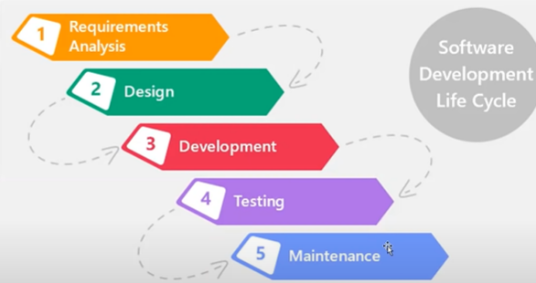

1. Water fall model:

Advantages:

* quality of product will be good
* since, requirement changing is not allowed that gives us the quality product
* initial investment is less as the tester will be hired at the later stages
* preferred for small project where requirement Is frizzed

Disadvantages:

* Requirement changes are not allowed
* Total investment is high because time taking for rework on defect is time consuming which leads high investment
* Testing will start only after coding

1. Spiral model:

* spiral model is iterative model
* spiral model overcome the drawback of waterfall model
* we follow spiral module whenever there is dependency of the module
* in every cycle new software will be released
* software will be released in multiple versions

advantages:

* testing is done in very cycle before going to the next cycle
* costumer will be able to use the software for every cycle
* requirement changes are allowed after every cycle before the next cycle

disadvantages:

* requirement changes are not allowed in between the cycle
* every cycle of spiral module looks like a waterfall model
* there is no testing in requirement and design phase

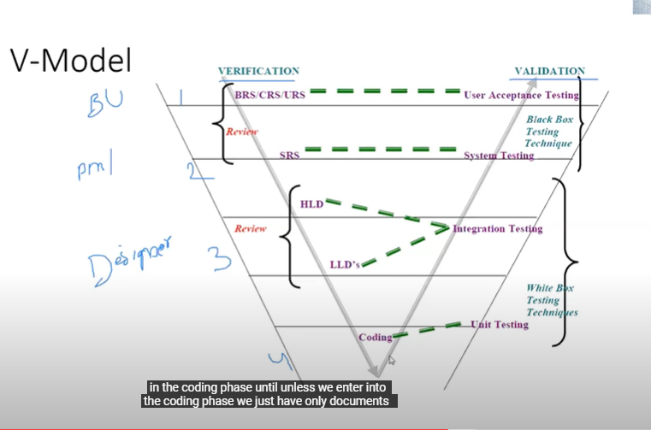

Static testing: testing the project related document in the form of review, walkthrough and inspection is called as static testing

Dynamic testing: testing the actual software

* Unit testing
* Integration testing
* System testing
* User acceptance testing

Verification:

* verification checks whether we are building the right product
* focus on documents
* verification typically involved
* reviews

Validation:

Validation checks whether we are building the right product

Validation takes place after verification is completed

Focus on software

Below technique are used to test the software

Unit testing, integration testing, system testing, UAT

Advantages:

* Testing is involved in each and every phase
* Chances of getting bugs Is very less

Disadvantages:

* Documentation Is more
* Initial investment is more

White box testing: after completion of code design developer reviews the code for correctness and completeness it is called as white box testing

We have to test the internal logic of program

In black box testing we check the functionality of the software whether it is working or not as per customer requirement or not

Static testing techniques

* Review
* Walkthrough
* inspection

Review: (can be done by single person)

Conduct on the documents to ensure the correctness and completeness

* Requirement review
* Design review
* Code review
* Test plan review
* Test case review

Walkthrough: (two or more peoples)

* + It is informal review that is no planning it can take place at any place at any time
  + Author reads the document or code and discuss with the peers, here the author is who have created the documents he is called as author he will go through each and every step and discuss with the rest of the people
  + It is not pre-planed
  + It has not any specific time to conduct

Inspection: (pre-planned)

It’s a most formal review type (the meeting moderator will arrange this meeting)

In which at least 3-8 people will sit in this meeting 1- reader 2- writer 3- moderator plus concerned

Inspection will have proper schedule which will be intimated via email to concerned developer and tester

* Reader: He is nothing but the author of the document
* Writer: this are the member who will raise the questions and not down all the question and clarification
* Moderator: he is the organiser of the meeting

Dynamic testing techniques:

* Unit testing
* System integration testing
* System testing
* User acceptance testing

* Unit testing: testing of code
* Integration testing: in this testing developer will integrate the different module and test them
* System testing: it is done by tester in which different test are tested
* UAT: It is tested by tester and costumer

QA, QC and QE

P- people (QC) tester

P-process (QA) high level management people, they will make sure the rest of the people are following the process or not whole SDLC process

P-product

QA: it is a process related

The whole SDLC process is involves in It

* Requirement analysis
* Design
* Coding
* Testing (QC)
* Deployment
* Maintenance

QC: it is actual testing of software

QA: focus on building a quality

QC: focus on testing for quality

QC: is for detecting defect

QA: is for preventing the defect if follow the process correctly

QC: is a product oriented

QA: is process oriented

QA: for entire life cycle

QC: for testing par tin SDLC

QE: quality engineering: automation tester

Level of testing:

Unit testing:

* + A unit is a single component or a module of the software
  + It conducts on single module or component
  + It is a white box testing technique
  + Conducted by developer

Unit testing technique

* + Basis path testing
  + Control structure testing
* Conditional coverage
* Loop coverage
  + Mutation testing

Basis path testing: every line should execute at least once that Is called as basis path testing

Control structure testing: this testing is used to increase the coverage area by testing various control structure

* Conditional coverage: in this testing we have to check the condition is giving the right output
* Loop coverage: loop is working properly or not

Mutation testing: repetition

In this we will test software by giving different input to check it is working properly or not testing the code with multiple types of data

Integration testing:

* Integration testing performed between two or more module
* Integration testing focuses on checking data communication between multiple module
* It is a white box testing technique

Types of integration testing

1. Incremental integration: incrementally adding the module and testing the data flow between the module

There are two approaches in the incremental integration

* + Top-down approach: incrementally adding the module and testing the data flow between the module, and ensure the module is added Is the child of the previous module
    - Example: in Gmail we first compose the email and then it goes to the sent tab and then if we delete then it goes to delete tab
  + Bottom-up approach: incrementally adding the module and testing the data flow between the module, and ensure the module is added is parent of previous module
  + Sandwich and hybrid approach: it is combination of top-down and bottom-approach

1. Non incremental integration testing: Adding all the module in single shot and test the data flow between them

Drawbacks:

* we might miss data flow between some of the module
* if you find any defect, we can’t understand the root Couse of defect

due to this drawback, we prefer incremental testing rather than using non incremental testing

system testing:

testing overall functionality of application with respect to client requirement

it is a black box testing technique

conducted by test team

after the completion of component and integration level testing, we start system testing

before conducting system testing, we should know the costumer requirement

the important aspects of system testing

* + user interface testing (GUI): UI of the application, all the images are properly aligned or not, logos, test box, check box, drop down, colour and fonts, navigation between the pages
  + functional testing: if we consider banking application like log in functionality, then check balance functionality, input domain, error handling, database testing
  + non-functional testing: security testing, performance testing, compatibility testing, load testing, volume testing, stress testing
  + usability testing: speed testing (how fast your application is responding to the customer while using the application) how friendly your application with the user

user acceptance testing: it is usually conducted by users or customer who are using the software if it working fine then they will send the software in live environment,

after completion of system testing UAT team conduct acceptance testing in two level

1. alpha testing: the user and customer do the testing in the development environment that is mean they come back to the company where software is developed
2. beta testing: then they will get the software and install the software in their environment and test it

system testing: get the requirement, prepare the test plan, test case, execute, finding the defect, reporting the defect, test execution report we have to prepare

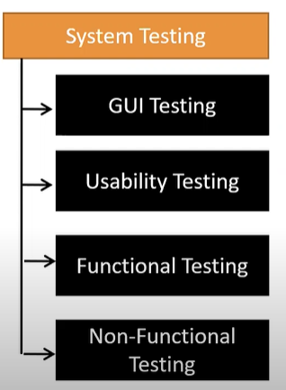

GUI TESTING: it is a process of testing the user interface of an application, the main focus is on the user interface of an application that is front end testing

A graphical user interface mainly countians element such as menus, check box, buttons, colours, fonts, sizes, icons, content and images

GUI testing checklist:

Look and fell of an application

* Testing the size position width and height of the application

Q) from where we can get this data?

Ans= it is in the design documents they will provide some document called as wireframe(dummy screen) with the help this we have to prepare some test case

* Testing the error message that getting displayed

If the text box has limit of 8 digit and we are giving more than it then the relative error message should be displayed

* Testing the different section of the screen

Like header and footer

* Testing the font whether they are readable or not

The heading should be in different font, then data, body of the text, link in other colour

* Testing of the screen with different resolution with zooming in and zooming out

It means after zooming in and zooming out the element should not be overlapped

* Testing the alignment of the texts and other element like icons, buttons, etc are in proper place or not
* Testing the colour of the fonts
* Image clarity
* Testing the alignment of image
* Testing of the speeling
* Testing the interface is attractive or not
* Testing of the scrollbars
* Testing the disabled field if any (if some text is disable then we should not be able to enter data)
* Size of image means it should be clear and small size like in kb
* Testing the colour of hyperlink
* Testing of the UI element like button, text box, text area, checkbox (F, M) we can select multiple, radio buttons (only one we can select), dropdowns and links

Usability testing:

During this testing validated the application provided context sensitive help or not to the user

We check how easily the end user are able to understand and operate the application is called usability testing

As a user point of I should be able to handle the application and can understand the document very easily

As a user it should be seem very easy and understandable if we found some difficulty in understanding the user manual we can concern with developer

Functional testing:

The behaviour of application whether it is working as per customer requirement or not

In functional testing suppose in text box it allows greater than 4 digit and which should be In upper case, it should contain some special character so we will test it that it is working as per requirement or not

Functional testing talk about how the application should work as per customer requirement

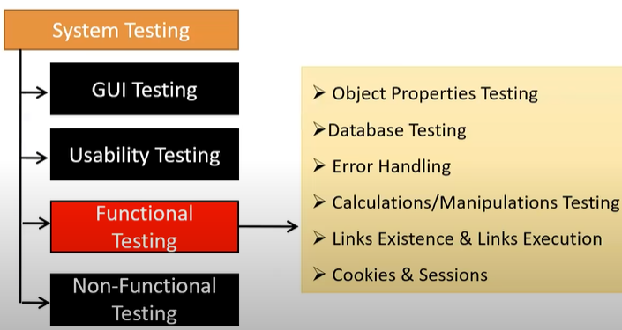

* Object properties testing:
* Database testing
* Error handling testing
* Calculation and manipulation testing
* Link existence and link execution
* Cookies and session

Object properties testing: if suppose there is one text box which can be disabled and enable if it is disable then user can not able to enter any data so enable and disable are the properties of the textbox another example like we can select either male or female this can be one property

Check the properties of the object present in the application

Ex: enable-disable, visible, focus

Database testing/ backend testing: checking the database operations with respect to user operations

DML operations: insert, update, delete, select,

In the databases testing whatever operations we are doing in the user interface that affecting the database or not, the communication between the UI and database working properly or not this mainly include DML commands

In the database testing we sending, updating, delating the data on the UI and other side we are running the SQL queries in the database the see the data from the table that is we are doing black box testing because we don’t know the coding part here and

At the backend we logging in the database and we are writing some queries here to check the any changes are happening or not it comes under the white box testing

So, in database testing the both techniques are used which is also called as grey box testing

Q) do you have something called grey box testing

Ans= black box tester having knowledge on internal structure it is called as grey box tester

Other than this there are some validation that are going to be done in database testing which is as follows:

* Table level validation (column type, number of columns in table, column length)
* Relation between tables
* Functions
* Procedure
* Indexes
* View
* Triggers

Error handling testing: tester verify the error message while performing the incorrect action on the application

* Error message should be readable
* User understandable/ simple language
* The specific error message should be displayed

Calculation and manipulation testing: tester should verify the calculations by passing different inputs

Link existence:

Where the links are placed ------------------------ link existence

Link are navigating to proper page or not ---- link execution

There three types of links

* Internal: it means whenever we click on link it will open in same page but different section
* External: In this when we click the link it navigates to the other page
* Broken links: link will be there but doesn’t have any action it will there for future purpose it does not have any target page

Cookies and session: cookies are the temporary files created by browser while browsing the page through internet

After successful log in on any website

Test design technique:

1. It is used prepare the data for testing
2. Data
3. coverage

Q) why we need test case design?

Ans = with the help of test case design we will get to know that the different features with in system are working as per requirement or not.

Test case technique will help us to reduce the data and also increase the coverage

There are five different techniques:

1. equivalence class partitioning:
   * + value check
     + classify the data into multiple classes
2. boundary value analysis:

We just verify the boundary of the value

There 6 parameters

Min

Min+1

Min-1

Max

Max+1

Max-1

Input domain testing:

The value will be verified in the text box / input field

Here we use ECP And BVA to prepare the test data

1. decision table-based (it is not testing)

if we have more no of condition/ action then we use decision table technique

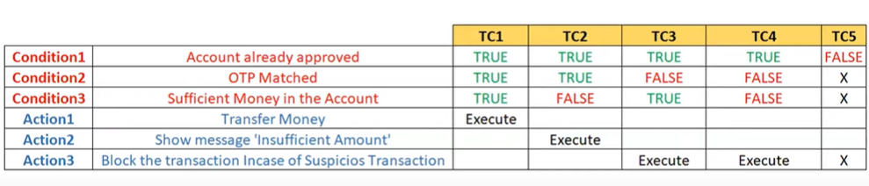

1. state transition:

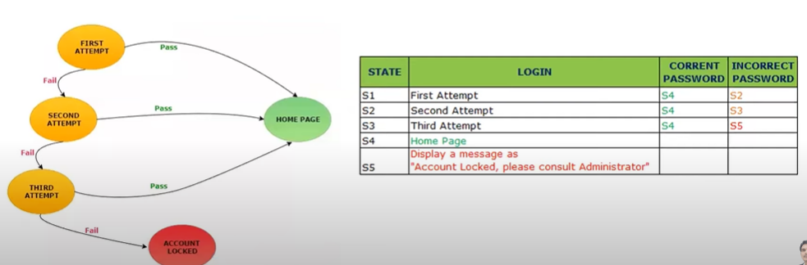

if we have multiple condition with respect to input

1. Error guessing: it is purely depended on tester analytical skill and their experience